New User Guide
Resources:
Information about using HPC systems and what they are:
- HPC-Carpentry.org
- HPC stands for high-performance computing and is the consolidation of computing resources used when more processing power is needed

Logging on to Hellgate:
To log on to the cluster you will need to be using campus internet
Once you are on eduroam you can connect to Hellgate through the command line using one of the apps below:
- Terminal (Mac or Windows)
- PowerShell (pre-installed on most Windows devices)
You will open up your app of choice and on the commands, line enter the below, making sure to put your netid. This will open a shell into Hellgate.
- ssh <netid>@login.rci.umt.edu
You will then be asked for your netid password (be careful as it won’t show what characters are being typed). By default, you will be put in your home directory.
- /mnt/beegfs/hellgate/home/<netid>
When your account is made you are put into the specified lab group. Users within the same lab group can share documents and access each other’s project and scratch spaces. Your home directory will only be accessible to you though.

Navigating with the Command Line:
Navigating Hellgate without a user interface can be intimidating but there are a few commands that will help you get around fairly easily.
- ls – lists contents in the current directory
- cd – used to change directories either one at a time or with absolute paths
  - cd <directory name>
  - cd /projects/<netid>
  - cd .. (moves outside a directory or up one level)
  - cd ~ (goes to home directory)
- pwd – prints absolute path location of where you are
- nano – text editor that lets you open a file a file and edit it
- cat – lets you read a file in the command line (can’t edit)
  - cat <file name>
- mkdir – makes a directory (folder) in the directory you are in
  - mkdir <new directory name>
- mv – used to move files between directories or rename files
  - mv <file name> <directory name>
  - mv <current file name> <new file name>
- rm – used to remove files
  - rm <file name>
- cp – used to copy files
  - cp <copied file name> <file name>

Layout of Hellgate:
When you logon on to the cluster you start in your home directory on the logon node, but this is not where you will store any files or data. The projects and scratch spaces are where you can run jobs, store data, and perform any other tasks you may need. Each location has different amounts of storage (if needed more storage can be requested).
- projects – 10TB (/mnt/beegfs /projects/netid)
- scratch – 5TB (/mnt/beegfs /scratch/netid)
- home directory – 500 GB (/mnt/beegfs/hellgate/home/$USER)
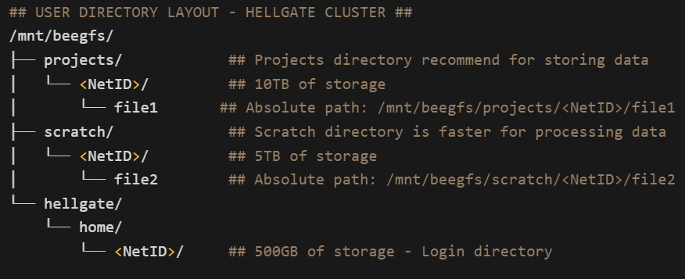

Moving Files To and From Hellgate Using SFTP:
We recommend that you use SFTP (Secure File Transfer Protocol) to upload and download data from the cluster. In this case uploading would be putting data onto the cluster and downloading would be getting data from the cluster back to your local machine.
First you would connect using SFTP, similar to how you would to Hellgate.
- sftp <netid>@login.rci.umt.edu
Your prompt should now begin with sftp. To exit type ‘exit’
- sftp> exit
The commands to move around and perform actions will differ whether you are on your local device or the remote device (hellgate). To navigate it will be the same commands as previously mentioned (Ex: ls, cd). To move around within your local device you will add an ‘l’ in front of the command.
- sftp> lcd <directory name>
  - this will move your to that directory on your local machine
In order to upload or download data you will need to be in the directory containing the files or use absolute paths.
To upload files to the cluster you need to be in the directory with the file and use
- sftp> put <file name>
To download files from the cluster you would use
- sftp> get <file name>

Scripts and Sbatch:
Scripts allow tasks to be automated by saving commands into a file, allowing you to easily re-run multiple commands at once. Scripts are in the form of a shell script and will end with the file extension .sh. To run a script there are two options and it doesn’t matter which you run.
- ./<script name>.sh
- /bin/sh <script name>.sh
On the cluster the most commonly used script will be a sbatch file, which is used to submit batch jobs to SLURM. Sbatch allocated resources for the script to use, making it easy for users to modify what resources they need. Scripts are dependent on the particular workflow and resources needed.
- Scripts can be edited with nano
- You can verify your job is running by looking at your current jobs with the command:
  - squeue -me

Slurm
Slurm allows you to request resources efficiently and has two main methods you will need: Sbatch and Srun.
Sbatch: This is a file used to submit jobs to Slurm. It specifies what resources and how many are allocated for the job.
Srun: This allowed for interactive jobs by having them run in the foreground. The output results from the job will go directly to your terminal and you will be unable to use the terminal until the job finishes. You can use tmux to detach from the shell session and let it run in the background, then use it to attach back if you want to check your progress.

Environments (Apptainer):
Apptainer is a containerization platform used on Hellgate. Containers allow you to quickly and securely run applications from within an environment that would otherwise not be able to run on Hellgate’s native environment. There is a sharded container directory with already built containers that all users have access to.
- /mnt/beegfs/projects/resources/Containers
Apptainer has two parts, a definition (def) file and a container binary (sif). The definition file will let you custom build your container and has two parts: a header and sections.
Header: defines the core OS to build
Sections: (optional) further configurations for the container
To build an Apptainer you can create one from scratch with a definition file or create them from external resources, such as Docker hub. To build from a definition file you will run:
- apptainer build <container_name> <def_file>
If you have any questions or would like further clarification, please put in a ticket through the Solutions Center.

